Virtual Routers
Support for multiple Virtual Routers (VRs) is an important security virtualization capability in the integrated firewall/VPN security device. A virtual router is a separate routing instance within the security device, with its own routing protocol, settings, route table, and routing updates. Each virtual router participates in its own routing domain. Multiple virtual routers allow the single device to participate in multiple routing domains completely separated from each other.
This separation adds a critical element of security to the routing functionality of the security device. It does this by having different routing instances for say Trust and Untrust, that completely hides the internal network addresses and topology information from any outside or untrusted network segments e.g. the Internet or other internal subnet. In addition to having a virtual router for Trust and Untrust, (all NetScreen integrated firewall/VPN devices have at least two virtual routers) multiple virtual routers support additional routing instances for additional security domains, especially important for managed security services.
In addition to the security benefit mentioned above, virtual routers also provide general administrative domain separation of routing for improved scalability and control.
The way it works is that security zones are assigned to virtual routers. A zone can only belong to one virtual router, and multiple zones can be assigned to the same VR. Zones that share a virtual router are in the same routing domain and thus have layer-3 reachability amongst each other. Zones assigned to a particular virtual router must not have overlapping IP address space, while zones defined to different VRs can have overlapping IP space or even identical IP space. Layer-3 reachability between virtual routers must be explicitly configured in routing tables, in addition to being enabled via security policy of course.
By default there is a Trust-VR and an Untrust-VR, with the default configuration having all zones assigned to the Trust- VR to allow “out of the box” IP connectivity. (Note: Again, all traffic must also be specifically permitted by a security policy for any IP connectivity to occur.)
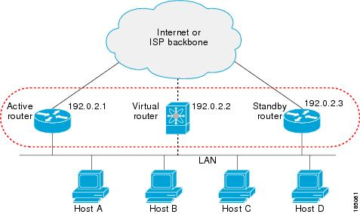

Multiple virtual routers also have a role to play in higher levels of virtualization in the NetScreen integrated firewall/VPN security solutions. While security zone functionality provides security segmentation, support for multiple virtual routers adds routing domain segmentation, that makes the device capable of supporting multiple truly separate domains within an enterprise, or among various customers in a Service Provider based managed security service offering.
A virtual router configured for use by one set of zones (or customer) is independent of other virtual routers of another set of zones (or customer). There is no exchange of routing information between virtual routers, and the routing updates from the one domain are not seen by the other domains. There is complete separation; that is unless the virtual routers are specifically configured to share information across with a static route or route export configuration. This is completely under administrative control.
Additionally, having multiple virtual routers adds the ability to support networks with overlapping IP address space, as long as the overlapping IP addresses/subnets belong to zones assigned to different virtual routers. Overlapping IP address space is quite common with multi-customer environments like a service provider, or large enterprise where acquisition or consolidation brings two previously separate entities together.
We have previously examined the basic building blocks of virtualization with VLAN based sub-interfaces, multiple security zones and multiple virtual routers. The combination of these capabilities creates the foundation for virtualized firewall and VPN services within a single device. It is the Virtual System or VSYS functionality that then adds the significant value in resource assignment, manageability and scalability of the virtualized system, especially important to larger scale implementations like a service provider offering network-based managed security services to it’s customers.

Virtual System (VSYS)
The NetScreen security systems can be logically partitioned into multiple firewall/VPN instances called Virtual Systems (VSYS), each with its own security zones, virtual routers, address book, policy rule set and management domain. It is t VSYS that segments a system into multiple security devices, and makes it practical to manage the multiple security domains that can range from the tens to hundreds. VSYS enables the single high performance security device to support multiple individual customers; leveraging the device cost and lowering overall total cost of ownership (TCO) with easier maintenance, management and support.
Once a custom VSYS has been created by the admin, it provides the logical segmentation to the system. Objects like address book entries, VPN tunnels, users, and policy rule set then get specifically created and modified under the contextual umbrella of the virtual system. The management interfaces are also specific to the VSYS being configured and managed-each VSYS appears as a discreet security device. This means that each distinct VSYS will have its own WebUI interface, and NetScreen Security Manager connections and views. Importantly, the administrator(s) of one VSYS are isolated to the configuration and operation of their own virtual system. This per VSYS management is crucial if customers are to be given a management interface into “their own” security system, and is also a necessity in environments where a single central administrator is responsible for configuring and maintaining a number of virtual systems in a complex multi-customer deployment.
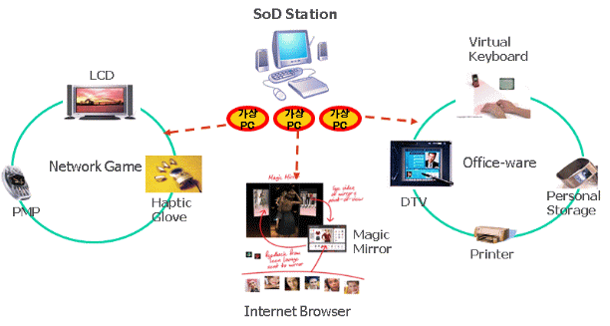
Additional per-VSYS resource configurations include:

• Authentication mechanisms
• Dedicated log information
• Web Filtering
• Deep Inspection
• Mapped IPs (MIP)
• Dynamic IPs (DIP)
• User defined services
• User defined Zones
• User database
Incoming traffic can be classified into a VSYS based on source and/or destination of the following in information; VLAN, Interface, or IP address, giving great flexibility in how VSYS gets deployed

In addition to the one or more custom VSYS, there is a ROOT VSYS that is controlled and administered by a central, overarching security and system administrator, who can access and configure all of the custom VSYS specific resources, as well as manage any shared resources, such as the SHARED-UNTRUST zone, which is a commonly shared connection to the Internet used by multiple internal security zones. The ROOT VSYS administrator also controls the initial assignment of interfaces, zones, and virtual routers to the specific custom VSYS, and also sets up the specific VSYS administrative accounts. Alternatively, all virtual systems can remain under the administration of the service providers ROOT ADMIN control in centralized management environments

